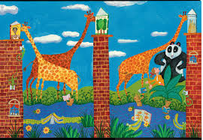
ED 320 Wild About Books!
Check off each genre as you complete it. You have complete choice of the books you read; the only requirement is that books should not have been read prior to this class. Two novels are required; the remainder can be picture books, easy read chapter books, graphic novels, etc.
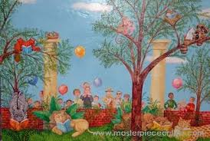

(Out of My Mind counts as one of your novels and fulfills the
realistic fiction genre requirement.)
Traditional Literature

Biography

Biography or
Autobiography

Historical Fiction

Poetry

Informational

Fantasy

Realistic Fiction

