Dear Class,

Life in 1940 for Evvy Hoffmeister is a scary time. She is only thirteen years old and has a disease called TB or tuberculosis. In 1940 TB was a deadly disease and many people died from it each year. Evvy is sent to a sanatorium in Minnesota to get well but it is a scary place for children with lots of very rigid rules to follow. Sometimes the patients are not even allowed to talk!

Luckily, there are other children as patients at the sanatorium that Evvy becomes friends with. But the patients all understand that TB is a disease that not everyone can recover from. You will come to feel a part of the group of friends at the sanatorium and feel as though you know the doctors and nurses as you read this interesting historical fiction story!

There are also great photographs from the time period and the author’s notes will give you so much good information about TB and this time period when sanatoriums were popular. Keep track of your questions as you read as some of them will probably be answered at the end but others will make good research questions!

Happy Reading!

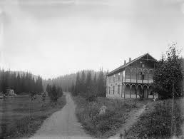
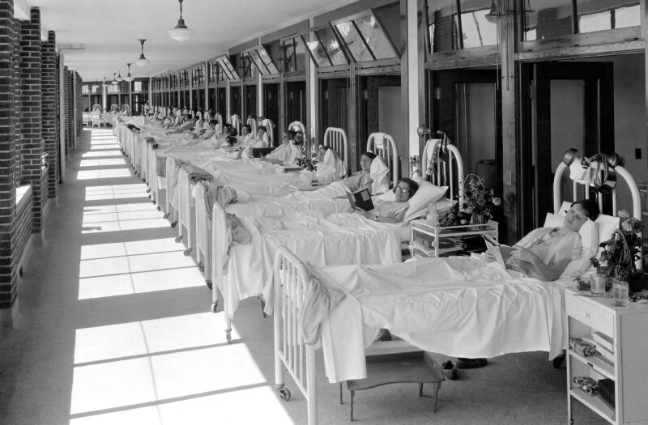
Professor Page

