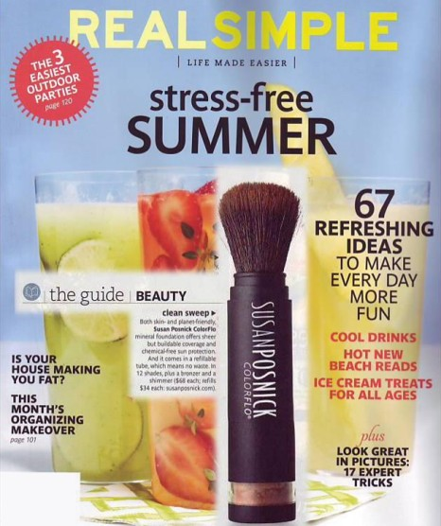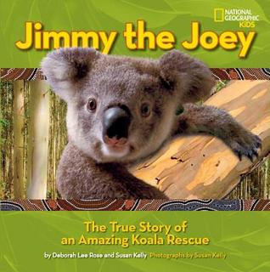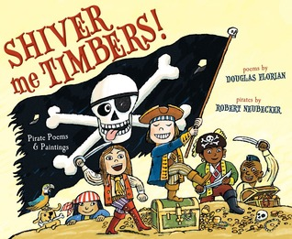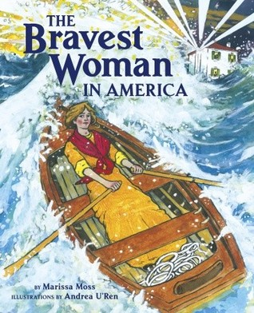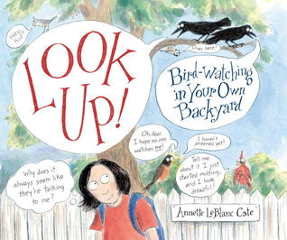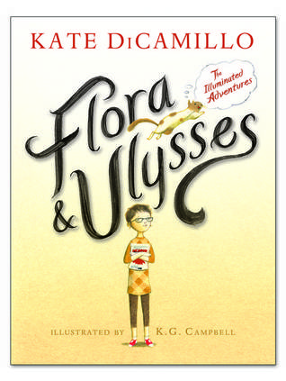 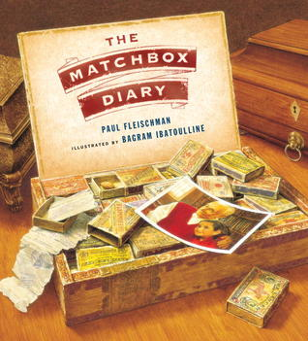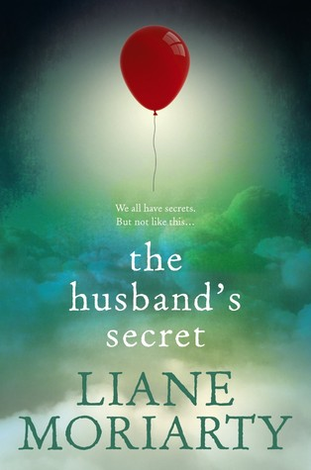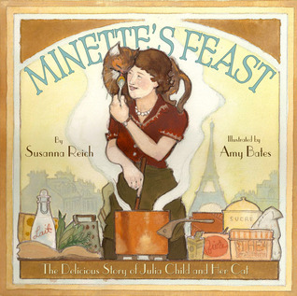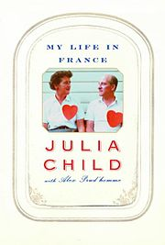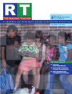 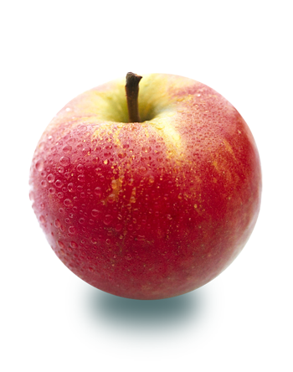

My favorite children’s book from summer 2013!

My favorite adult book of the year! After visiting Paris I loved reliving my trip and reading of Julia’s adventures. Then I found the children’s book about Julia’s cat!

# Mysteries & thrillers are

# my favorites!

* I read reviews from several websites and blogs for children’s books and current fiction. For professional books I visit some of my favorite publishers: Heinemann, Stenhouse, International Reading Association. My favorite blog for children’s books is Mr. Schu ‘s!
* Recommendations from friends . . . My friends all enjoy the same types of books and many of the same authors that I do!
* Reviews I read in the newspaper and magazines.
* Look for books of authors I enjoy reading.
* Finding books about topics I need to read about.
* I have always kept a list of “books to read” to remind myself of good books I want to read. It used to be a notebook but now it is on my computer!

**The Reading Teacher**

This publication also is delivered to me online so sometimes I read the paper copy, sometimes the online. It is full of reading research-based ideas for using in elementary to middle school aged classrooms. I have been reading this for over 20 years.

**Grand Rapids Press**

I do read the newspaper often. I usually read the paper or look at news online daily.

Magazines are my “break” reading. I might take a month to read a magazine as I read them in short spurts.

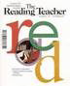

#### How Do I Decide What to Read?

### I enjoy reading a variety of genre and authors! Most of all I HAVE to read!

Favorite Places to Read!

* In the hammock at my cottage
* On a beach
* On the couch on my sun porch
* In bed after watching the news at night
* In the car on trips

# Children’s books . . . sheer joy!

Welcome to Pam’s Reading Life

Fall 2013